**ASSIGNMENT 1- 20/03/2025**

**TechShop, an electronic gadgets shop**

**Task 1: Database Design**

1. 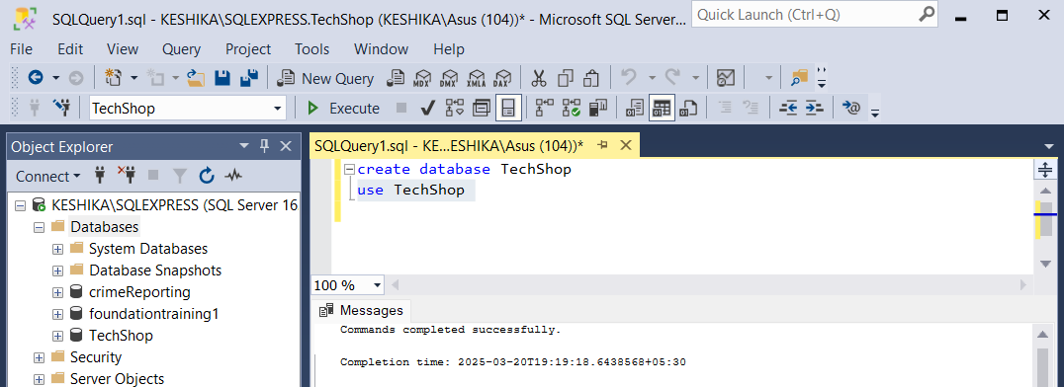Create the database named "TechShop"
2. Define the schema for the Customers, Products, Orders, OrderDetails and Inventory tables based on

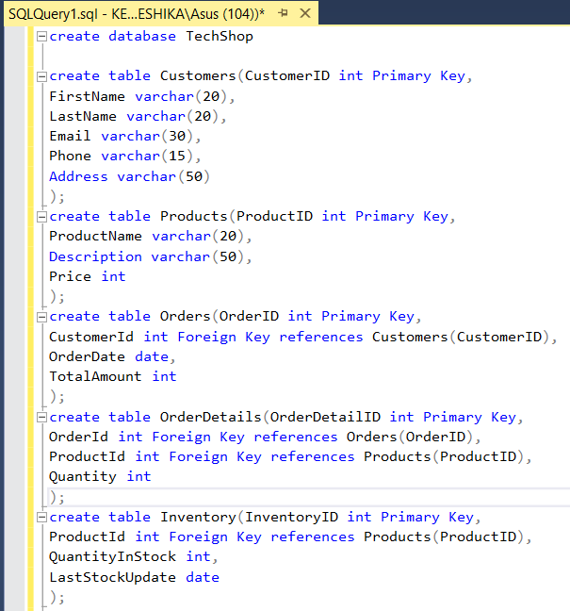 the provided schema.

3.Create an ERD (Entity Relationship Diagram) for the database.

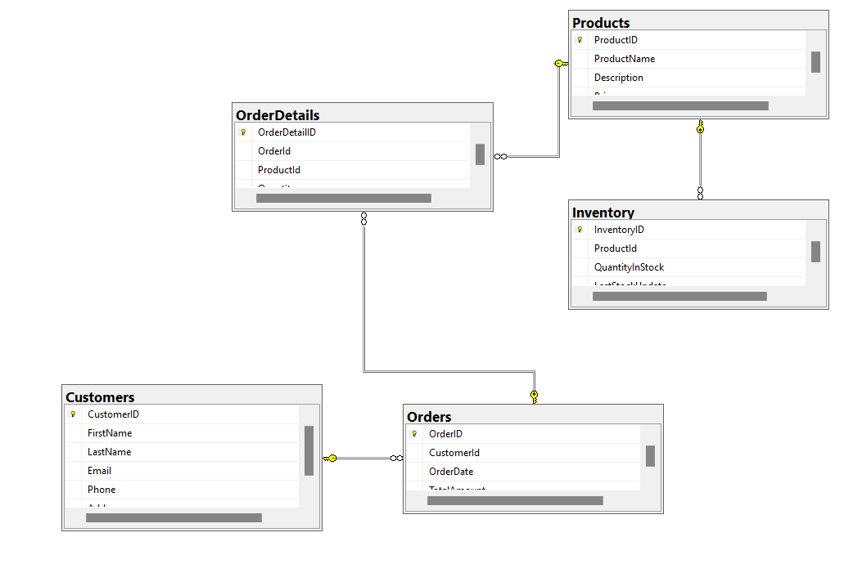

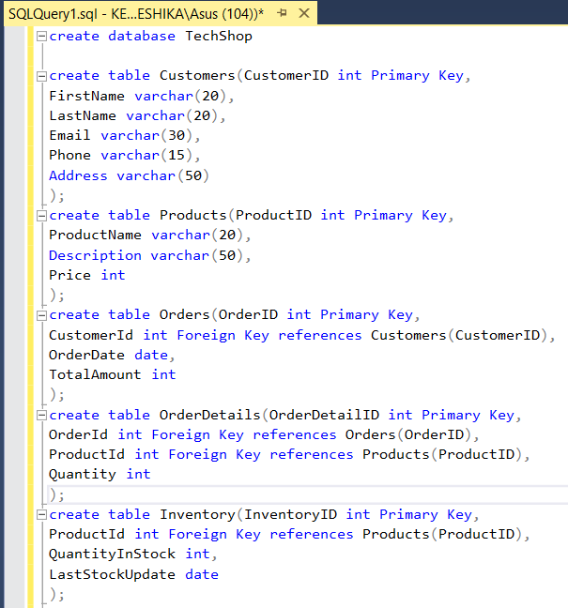4.Create appropriate Primary Key and Foreign Key constraints for referential integrity.

5.Insert at least 10 sample records into each of the following tables.

a. Customers b. Products c. Orders d. OrderDetails e. Inventory

**a. Customers**

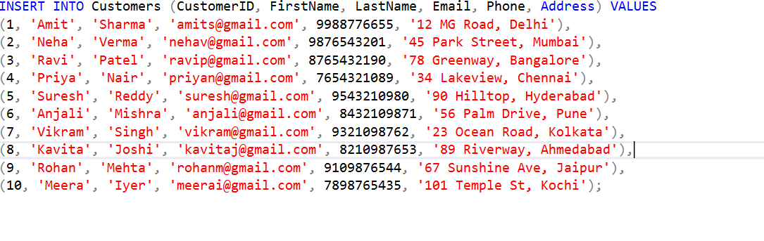

**b. Products**

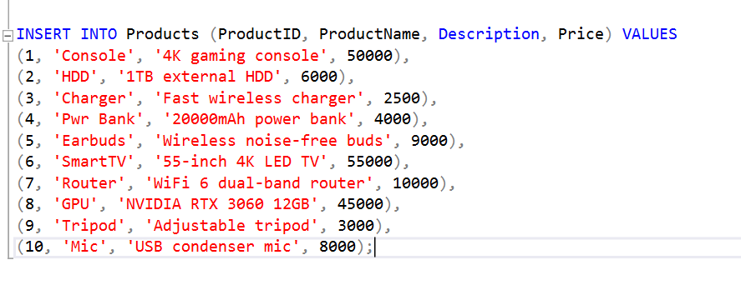

**c. Orders**

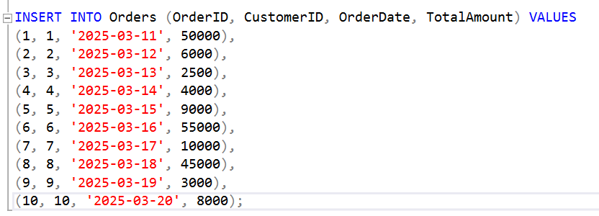

**d. OrderDetails**

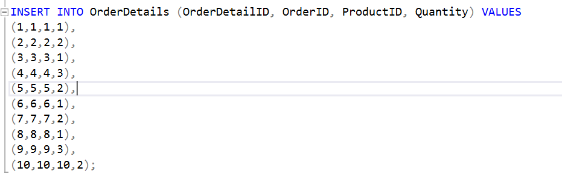

**e. Inventory**

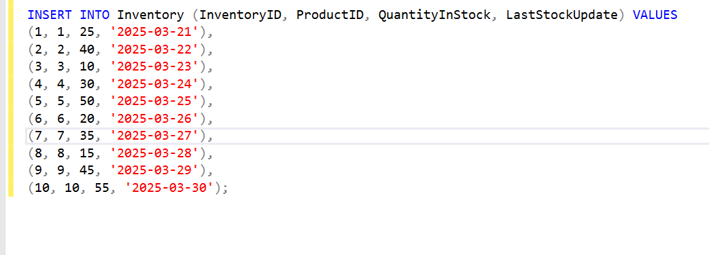

**Tasks 2: Select, Where, Between, AND, LIKE:**

**1.Write an SQL query to retrieve the names and emails of all customers.**

**Command:**

SELECT FirstName, LastName, Email FROM Customers;

**2. Write an SQL query to list all orders with their order dates and corresponding customer**

**names.**

**Command:**

SELECT q.OrderID, q.OrderDate, e.FirstName, e.LastName FROM Orders q JOIN Customers e ON q.CustomerID = e.CustomerID;

**3. Write an SQL query to insert a new customer record into the "Customers" table. Include**

**customer information such as name, email, and address.**

**Command:**

INSERT INTO Customers (FirstName, LastName, Email, Phone, Address)

VALUES ('Isha', 'janu', 'isha.janu@example.com', '9876543211', 'Coimbatore, Tamil Nadu');

**4. Write an SQL query to update the prices of all electronic gadgets in the "Products" table**

**by increasing them by 10%.**

**Command:**

UPDATE Products

SET Price = Price * 1.10

WHERE ProductName LIKE '%Laptop%' OR ProductName LIKE '%Smartphone%'

OR Description LIKE '%electronic%' OR ProductName LIKE '%Tablet%';

**5. Write an SQL query to delete a specific order and its associated order details from the**

**"Orders" and "OrderDetails" tables. Allow users to input the order ID as a parameter.**

**Command:**

DECLARE @OrderID INT = 3;

DELETE FROM OrderDetails WHERE OrderID = @OrderID;

DELETE FROM Orders WHERE OrderID = @OrderID;

**6. Write an SQL query to insert a new order into the "Orders" table. Include the customer**

**ID, order date, and any other necessary information.**

**Command:**

INSERT INTO Orders (CustomerID, OrderDate, TotalAmount)

VALUES (2, GETDATE(), 12000.00);

**7. Write an SQL query to update the contact information (e.g., email and address) of a**

**specific customer in the "Customers" table. Allow users to input the customer ID and new**

**contact information.**

**Command:**

UPDATE Customers

SET Email = 'lily@gmail.com',

Address = 'Gandhinagar, chennai'

WHERE CustomerID = 1;

**8. Write an SQL query to recalculate and update the total cost of each order in the**

**"Orders" table based on the prices and quantities in the "OrderDetails" table.**

**Command:**

UPDATE O

SET TotalAmount = (

SELECT SUM(P.Price * OD.Quantity)

FROM OrderDetails OD

JOIN Products P ON OD.ProductID = P.ProductID

WHERE OD.OrderID = O.OrderID

)

FROM Orders O;

**9. Write an SQL query to delete all orders and their associated order details for a specific**

**customer from the "Orders" and "OrderDetails" tables. Allow users to input the customer**

**ID as a parameter.**

Command:

DECLARE @CustomerID INT = 4;

DELETE OD

FROM OrderDetails OD

JOIN Orders O ON OD.OrderID = O.OrderID

WHERE O.CustomerID = 2;

DELETE FROM Orders WHERE CustomerID = 2;

**10. Write an SQL query to insert a new electronic gadget product into the "Products"**

**table, including product name, category, price, and any other relevant details.**

**Command:**

INSERT INTO Products (ProductName, Description, Price)

VALUES ('Bluetooth Speaker', 'Portable electronic speaker with bass boost', 3500.00);

**11. Write an SQL query to update the status of a specific order in the "Orders" table (e.g.,**

**from "Pending" to "Shipped"). Allow users to input the order ID and the new status.**

**Command:**

ALTER TABLE Orders ADD Status VARCHAR(50);

DECLARE @OrderID INT = 2;

DECLARE @NewStatus VARCHAR(50) = 'Shipped';

UPDATE Orders

SET Status = NULL

WHERE OrderID = 1;

**12. Write an SQL query to calculate and update the number of orders placed by each**

**customer in the "Customers" table based on the data in the "Orders" table.**

**Command:**

ALTER TABLE Customers ADD OrderCount INT

UPDATE Customers

SET OrderCount = (

SELECT COUNT(*)

FROM Orders

WHERE Orders.CustomerID = Customers.CustomerID

);